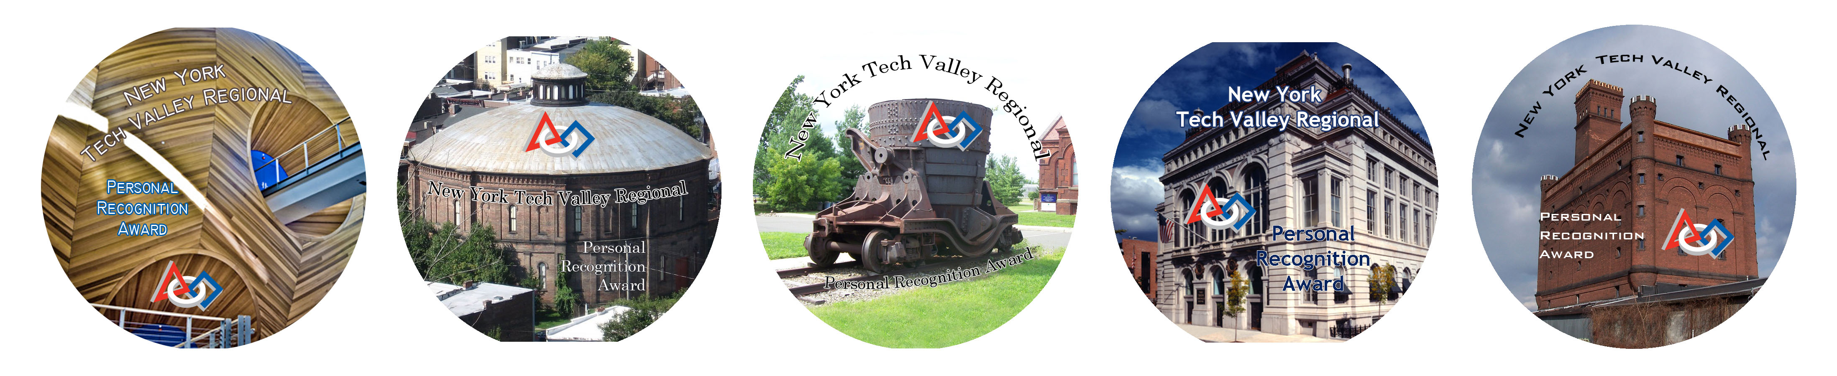

** A FIRST Award Opportunity! **

New York Tech Valley Regional

Personal Recognition Award Procedure

New York Tech Valley Regional Attending Teams:
FIRST is all about recognition and inspiration. This absolutely holds true for the FIRST New York Tech Valley Regional event. To further encourage each of us to create the world we would love to live in, FIRST is once again providing a special, limited edition, FIRST NEW YORK TECH VALLEY REGIONAL PERSONAL RECOGNITION BUTTONS. This button will not be distributed freely, but must be EARNED by an individual.
The way it works...
Each team participating in the Finger Lakes Regional will receive a packet containing 5 (five) PERSONAL RECOGNITION buttons and a Personal Recognition Data Form for each button. Each team should plan to award a button to an individual at the event who should be recognized for outstanding behavior in any of the following areas:

* Gracious Professionalism
* Helpfulness
* Spirit / Enthusiasm
* Extreme Safety
* Bringing People Together

Individuals could be members of another team, FIRST staff, venue staff, the concierge at your hotel, or the driver of your bus. Assessing individuals to recognize is going to be somewhat subjective. However, the overriding factors are actions "Deserving Special Recognition."
Not only will recognized individuals receive a limited edition button, but the team awarding the button should also record the name, team number or other affiliation, and reason for the recognition on a Personal Recognition Data Form at the time of the award. Each button you present should have an accompanying form. The forms should be turned in at the Pit Administration Table by noon on Saturday. Please complete this short form! Information about recognized individuals from all forms returned will be posted in a special location on the Rolling Thunder website (penfieldrobotics.com/events/pra.php) shortly after the competition.
So put your Gracious Professional game-face on and do what you always do at FIRST competitions, create an environment we all wish we lived in everyday and please take the time to recognize someone who deserves a FIRST New York Tech Valley Regional Personal Recognition Button!

Go Tech Valley Teams!
TEAM NUMBER (this is the team giving the award) _______________________________

- Write name of recipient and check box that indicates reason for recognition.

REASON FOR RECOGNITION

Recipient Name | Team # or affiliation | Gracious  Profess. | Helpful-ness | Spirit / Enthusiasm | Extreme Safety | Bringing People Together

(2) Write a brief description explaining more specifics about the reason for recognition.

TEAM NUMBER (this is the team giving the award) _______________________________

- Write name of recipient and check box that indicates reason for recognition.

REASON FOR RECOGNITION

Recipient Name | Team # or affiliation | Gracious  Profess. | Helpful-ness | Spirit / Enthusiasm | Extreme Safety | Bringing People Together

(2) Write a brief description explaining more specifics about the reason for recognition.

TEAM NUMBER (this is the team giving the award) _______________________________

- Write name of recipient and check box that indicates reason for recognition.

REASON FOR RECOGNITION

Recipient Name | Team # or affiliation | Gracious  Profess. | Helpful-ness | Spirit / Enthusiasm | Extreme Safety | Bringing People Together

(2) Write a brief description explaining more specifics about the reason for recognition.

