Junior FIRST LEGO League

 | FIRST LEGO League (FLL) will continue the Junior FLL experience for the 2006 season in the North America. This exciting opportunity for younger budding scientists will introduce the core concepts of all FIRST programs to inspire, excite, and introduce children to the wonders of science, technology, and engineering.
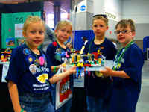
Created in partnership with the LEGO Group, JFLL is geared to children aged 6 to 9 years old and utilizes a modified FIRST LEGO League framework. Teams of up to 6 children and an adult mentor receive a mini challenge, based on the annual FLL research project. Using an open-ended LEGO building set, they will design a model depicting an aspect of this year’s "Nano Quest" Challenge. Children will spend approximately one month exploring, investigating, designing and building a model made with LEGO bricks. In conjunction, teams create a "Show Me" poster that depicts the teams’ experience during this process, through drawings and words.

Teams celebrate and share their experience with other teams, family and friends at local events or at an official JFLL Expo. The celebration includes time to enhance the teams’ current models and show their poster, meet with friendly "Reviewers" to share their experiences, and receive recognition for their efforts.
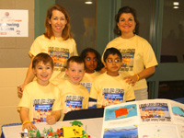
JFLL introduces children to the concepts of teamwork and basic design skills, creating an initial interest and hands-on approach to science and technology through the familiarity and fun of LEGO building. The goal: provide an experience that will begin to transform youngsters and open their eyes to the possibilities of improving the world around them through acknowledgement, thought, planning and technology.
The JFLL experience also is a way of engaging younger siblings and friends of FLL team members in a similar team situation with goals. By cultivating their interest in and experience with this kind of hands-on, fun teamwork, they are likely to then transition to the FLL program, as they get older.
The 2006 JFLL program registration will be held August 1, 2006 – September 29, 2006. The registration fee for this season is $90, which includes a LEGO base kit of more than 1,100 pieces. For teams attending an official JFLL Expo, there will be a separate registration fee collected at the event.

