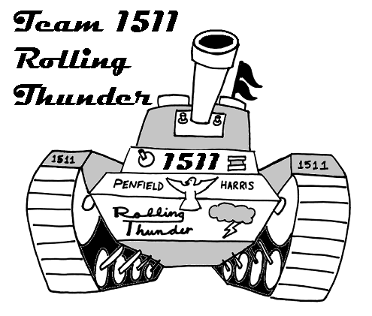
Dear Parent/Guardian,
Kimberly O’Toole
1680 University Ave
Rochester, NY 14610
585-242-3353
kotoole@harris.com December 17, 2004

It was great to meet those of you who could make the parents meeting! For those of you who could not make it (and did not already email me), I have enclosed the presentation given, with notes on what was discussed. We hope your student is enjoying the program, and we are all getting excited for the kickoff event on January 8th!!

We still have a lot to accomplish for this team, and I and the other mentors are doing everything we can to get it all done. However, we could still really use some help, and are hoping to get the parents involved. In most cases the tasks are simple; we just don’t have enough people to do them all. Please take a second look at what we need help with here, and fill out the enclosed form. You can return it to us in the stamped envelope provided, or you may email me at the above address. If you have circumstances where you are unable to help at all, please check the “not interested” box and return the form so that we do not bother you with further mailings. I have prioritized the items in order of importance to the team.

- Food Arrangements
- Fundraising Support
- Travel Arrangements
- Chaperones
- Donations
- Exhibition Organization
- Field Construction
- Volunteer at Competitions
- Team Spirit
- Engineering Design/Support

Please fill out & return the attached form by Wednesday, January 5th. Following January 5th, we will be making phone calls to remind families about the form, and obtain sign ups.

I have also enclosed the Wish List/Fundraising list for reference. Please feel free to contact me or Linda Martina if you have any questions. Thank you!!

Sincerely,

Kimberly O’Toole & Linda Martina

