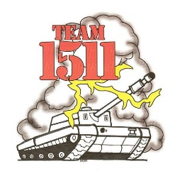
Penfield High School
25 High School Drive
Penfield, NY 14526

Dear Potential Patron,

Thank you for taking the time to speak with us today. We are seeking sponsorship for the Penfield High School Robotics team as a part of the FIRSTTM program. We will be providing nearly 70 team members with the opportunity to travel to cities like Rochester, Boston and Philadelphia for Regional Competitions, and to Atlanta Georgia for our Championship Competition. Our team needs to raise more than twenty-five thousand dollars to support this goal.

FIRST is a robotics competition founded by inventor Dean Kamen. FIRSTTM, an acronym for “For Inspiration and Recognition of Science and Technology,” is an international phenomenon, which pairs high schools with corporate engineering sponsors to build a robot which will compete in a sport-like event. The goal of the FIRSTTM program is to give students hands-on experience working with real engineers, so that engineers and scientists are seen as role models in the same way professional athletes are.

Support of our team offers many benefits to the community. Local students will have the chance to learn and develop many new skills. They will be learning not only engineering and design skills, but will also be developing leadership, business, public speaking, coaching, and communication skills. We are looking to provide these students the necessary skills to become the next leaders in our community and beyond.

We are offering several ads in response to your donation. Donations can be any size of monetary contribution that you would be willing to provide us. We will be producing a patron book in May that will be displayed throughout local communities and with every patron. This book will contain ads per the following donation levels: $10 for a one line ad, $25 for ¼ page, $50 for ½ page, $100+ for a full page. Donations of $200 will obtain a small ad space on our T-shirts, and donations of $500 or more will obtain ad space on our robot. See the attached page for details. The local Regional Competition, held at RIT on March 5-7, 2009 will be televised on local news stations and other TV stations. The Championship competition is often covered by ABC, 60 Minutes, and similar shows. All donations are tax deductible as it is a school club contribution.

Thank you, once again, for speaking with us today and we look forward to your patronage!

Sincerely,

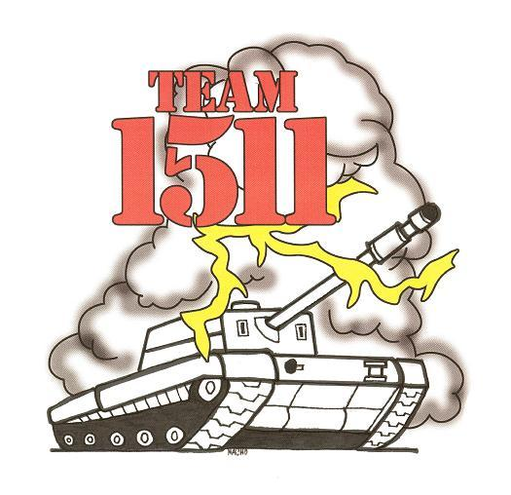
(Student Name) & The Penfield High School Robotics Team
1 Line $10 --------------------------------------------------------------

½ Page $50

All Patrons will be displayed on our webpage: www.penfieldrobotics.com

¼ Page $25

Sample Patron Book Page

$100: 1 Full Page

$200: Name on T-shirt
And 1 Full Page

$500: Name on Robot
Name on T-shirt
And 1 Full Page

$5,000 and up:
Full Team Sponsor
(Name in Team Name)
Name on Robot
Name on T-shirt
And 1 Full Page

